
Narrative for 3.10.2 Invasive Species management and protection
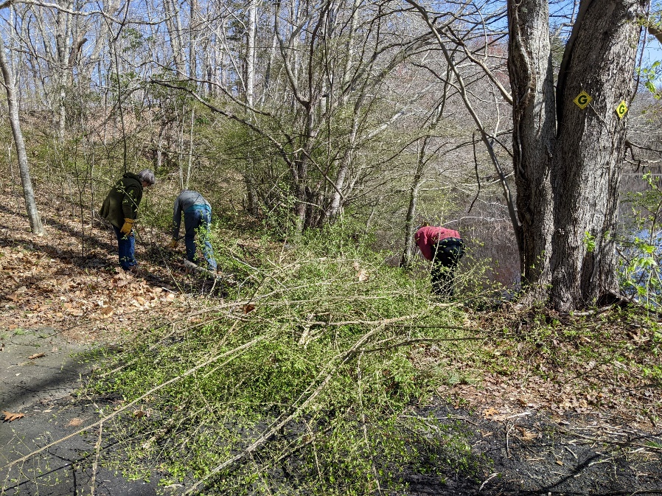
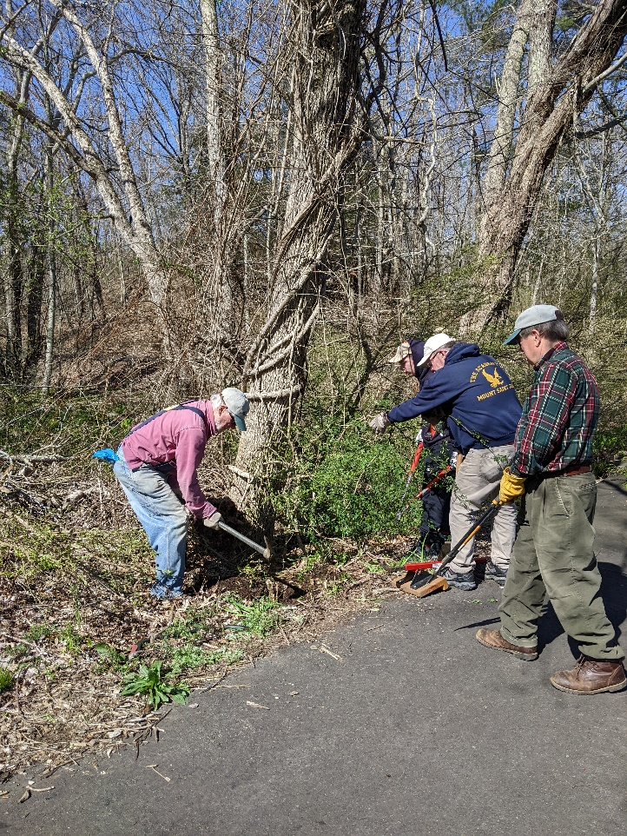
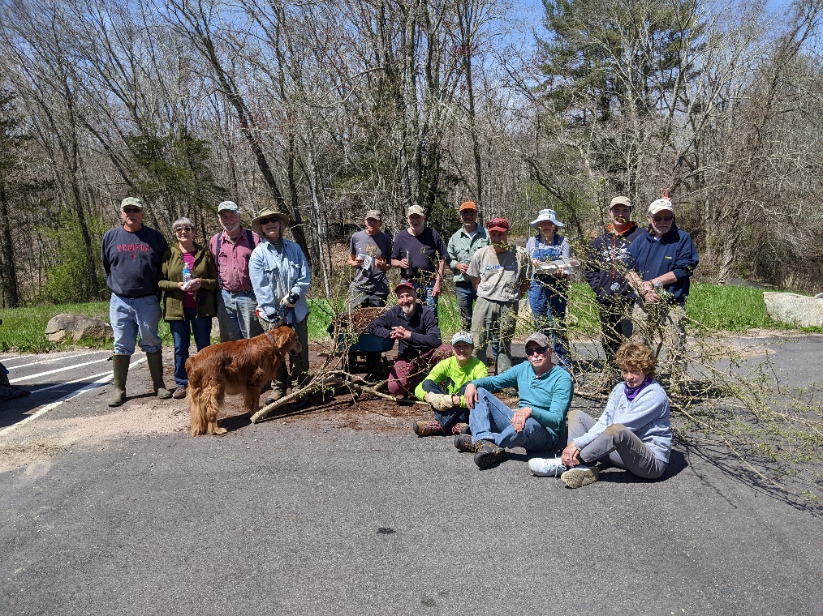
The Conservation Commission has taken upon itself to slowly replace invasive species in town reserves with Native Species. In 2021 and 2022 groups of volunteers cleared invasives, mostly burning bush in a section of Chapal Reserve to make way for planting of native plants. Photos from April 23 2022
Volunteers eradicating Bitter Root in Chapal Reserve
Volunteers of Conservation Commission who eradicated Burning Bush and Bitter Root in Chapal Reserve
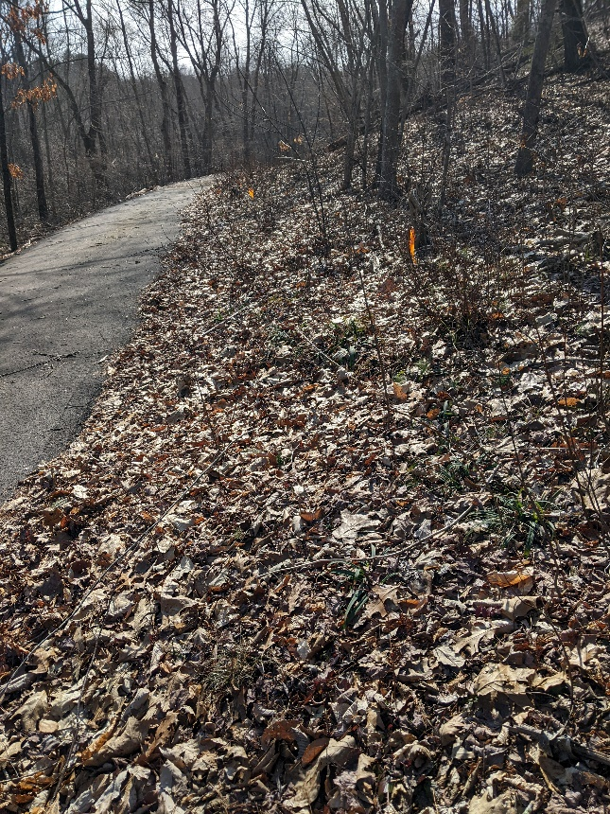
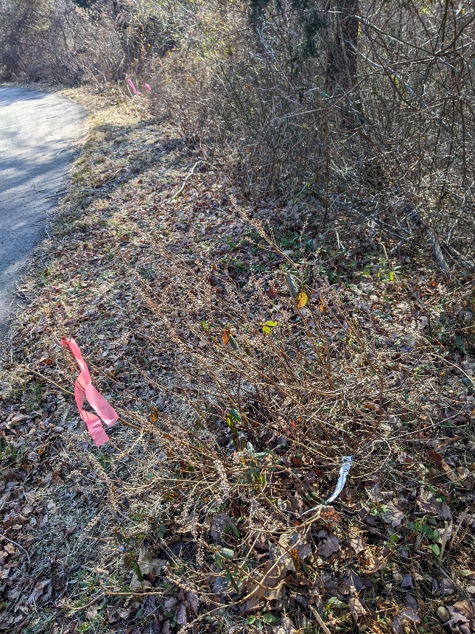
In early spring of 2024 one can see the cleared area. Some of the burning bush has returned but the Summer Sweet and other native plants that were planted in the cleared area have a good chance of making it and competing with the burning bush. The summer sweet plantings are tagged with orange. Other Natives were planted in cleared areas.

The East Haddam Land Trust also targets Invasives in their Preserves. A section of Ayers Preserve was cleared of Burning bush and Bitter root in a forest management project which plans to encourage resurgence of oaks in an area that had been an abandoned Christmas tree farm with spruces that became overgrown and started falling and dying. The area was cleared of the spruce trees and volunteers from the Land Trust, the Conservation Commission and the Sustainability Team worked on the eradication. January 28, 2023

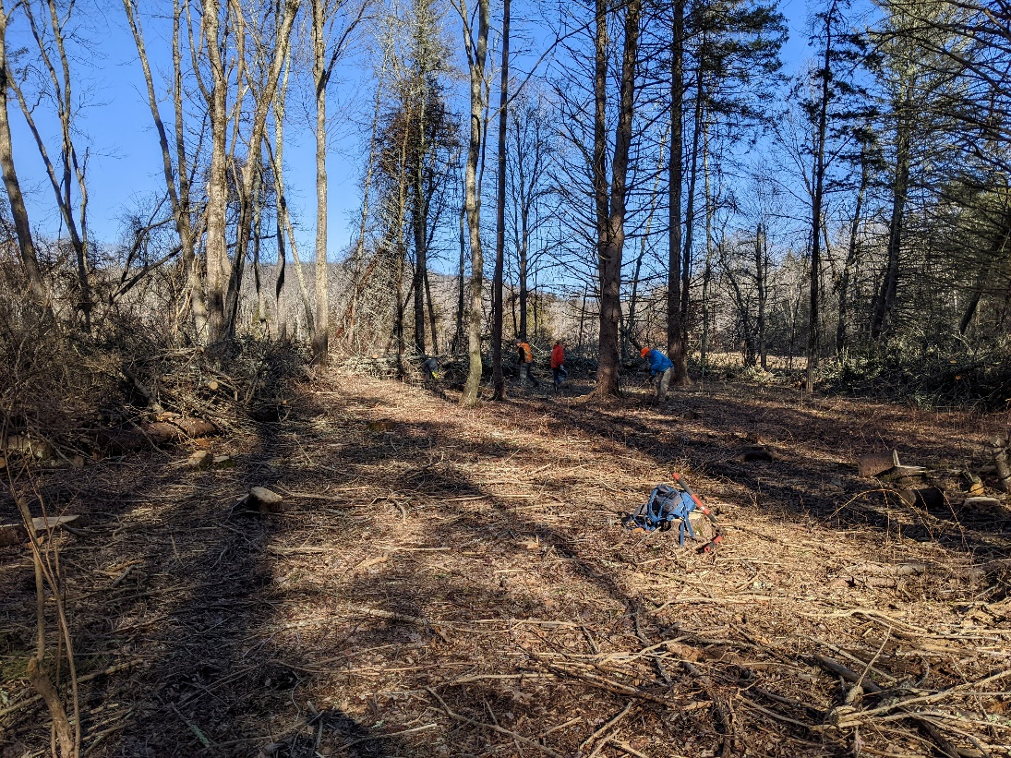
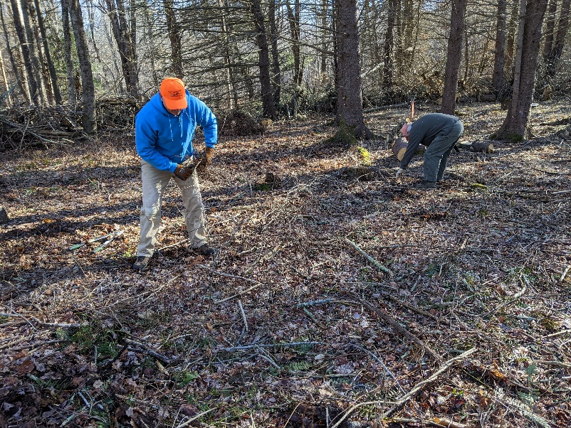
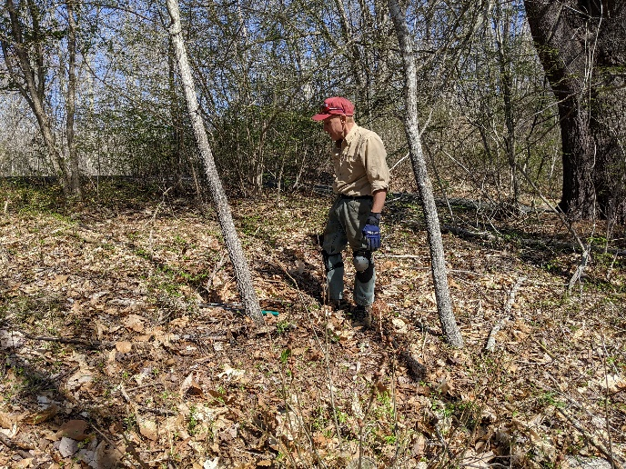

The Moodus Reservoir Preservation Group Is working to control invasive hydrilla in the Moodus Reservoir. In 2017 they decided to purchase a harvesting machine that will pick up the Hydrilla from the water. The machine was delivered in 2021 and has been in use since. The town has contributed to the purchase of the machine.

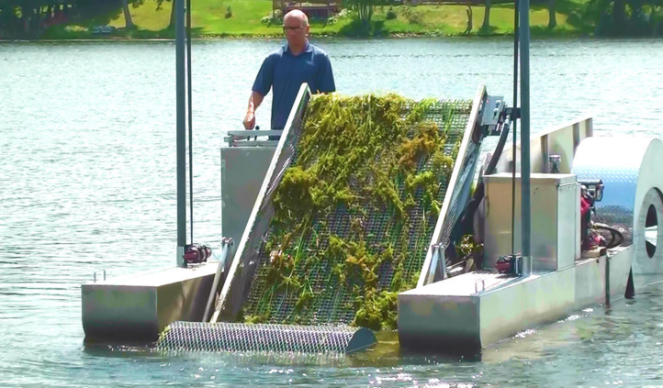
http://www.moodusreservoir.org/about-us.html is the narrative in MRPG. They are also considered in the town budget as the town contributes financially to the MRPG management efforts. https://town-east-haddam-ct-budget-book.cleargov.com/14500/departments/lakes-association

