Implement Complete Streets

6.1.2
First Selectman Laura Francis and Cathy Bisceglia attended a “Vibrant Main Street” Conference in October 2019. The Bridge, “Creating Walkability…the First Steps” 11.8.2019 https://ctmainstreet.org/events/creating-walkability-the-first-steps/

Leslie Bulion attended BikeWalkCT technical training June 9, 2017. http://www.bikewalkct.org/bike-walk-summit-2017.html

Martin Anderson Implementing Complete Streets and Vision Zero in Connecticut
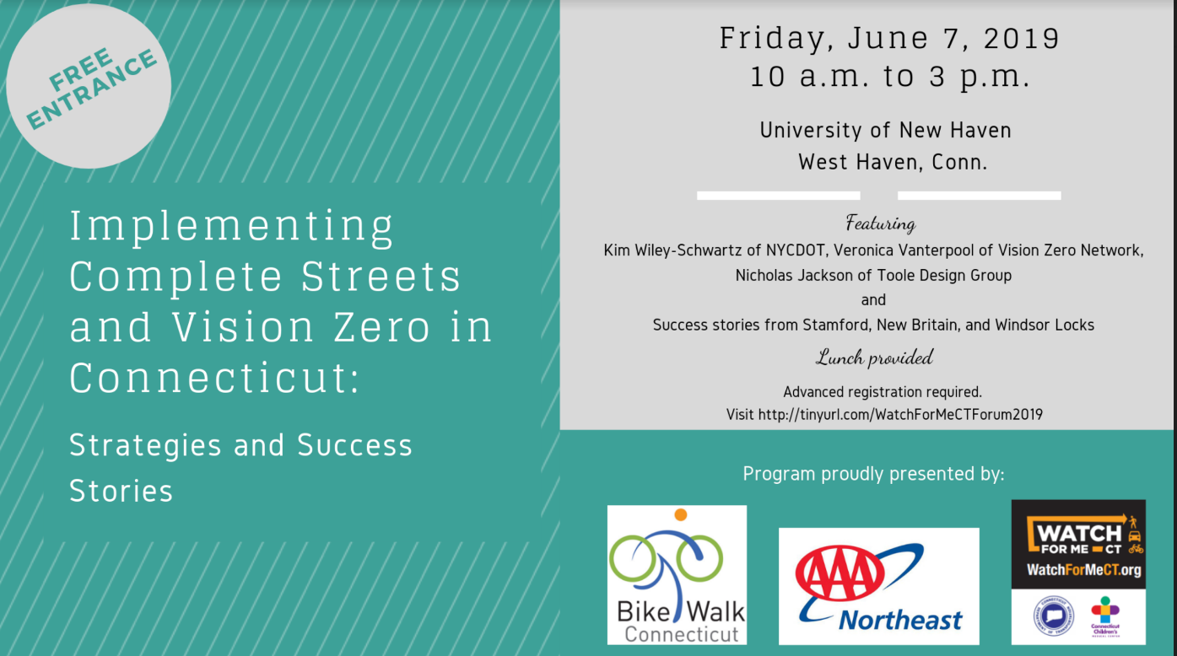
Leslie Bulion, Cathy Bisceglia, Becky Anderson attended STEP webinar April-May 2020 (see accompanying certificates).

Supporting Documents
- Certificates of Completion of Trainings (pdf)

