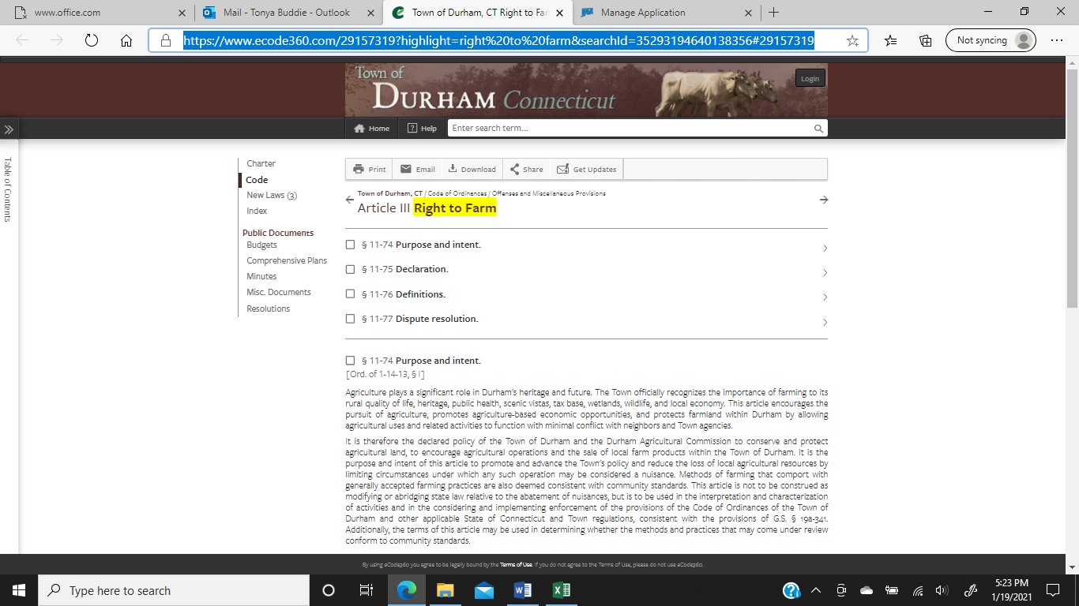

Town of Durham, CT Right to Farm (ecode360.com)

