August 2020 Town of Stratford Communications Strategy

Mission.

To promote clear, transparent, inclusive, accurate, and timely communications of all Town services, notifications, and events for all residents of Stratford.

Goals.

- To convey Town messages/notifications to as many residents and businesses as possible in the most effective ways.
- To provide all Town related communications in a professional and timely manner.
- To be responsive to resident’s needs and promote Town messaging via both one-way and two-way communication platforms.
- To make Town Hall easily accessible to residents.
- To include strategies that foster equity and diversity in Town’s communication channels.
- To continuously monitor and evaluate the effectiveness of existing communications platforms in reaching targeted populations and adapt to changing needs.
- To update information shared on communication channels on a regular basis.
- To foster meaningful partnerships with local media and community partners and utilize these partnerships to further maximize public outreach.
- To solicit community feedback via two-way communication platforms and convey residents’ complaints (if any) to relevant Town Department.
- To enhance resident engagement and participation in the Town through multi-faceted and flexible communication channels.
Target Audiences.

- All residents of the Town, including disabled population, ethnic communities, marginalized population, immigrants, and LGBT communities
- Property Owners
- Businesses
- Religious and charitable institutions/Non-profits
- Educational institutions
Summary of Strategy.

Active media relations efforts are maintained by the Chief of Staff in Mayor’s Office as well as individual departments.

The Chief of Staff is responsible for managing public relations with the Mayor’s Office and the timely delivery of all messages initiated by the Mayor’s Office via local/regional print media, radio and television network, Mayor’s newsletter, and all social media websites. Departments interested in sending messages via Mayor’s Newsletter and Mayor’s “Town of Stratford” social media accounts convey these messages to the Chief of Staff, who publishes this information. Departmental level information is also shared via respective departments’ Facebook page.

The Town Hall website is managed by the Town’s IT Manager. All Departments are responsible for maintaining their respective department webpages. They send website update requests to the IT Manager, who updates these webpages as soon as he receives the requests. The IT Manager also assists with additional electronic communication channels (such as GoToMeeting digital meeting app) as necessary. All scheduled meetings of Town Boards/Commissions and public meetings held in Town Hall chambers are recorded by IT Department and shared via local television channel (Channel 79). These recordings are also uploaded online on Town Website by the IT staff.

An important feature of the Town Hall website is the “Community” link where the Community Calendar of events is posted and updated regularly. A sub-link to Channel 79 is also posted within this link. Other sub-links include “Emergency Preparedness”, which has emergency contact information, crime prevention information, fire safety information, etc.; “Celebrate Stratford” and “Restaurant Week”, which provide information on local festivals, events, etc.; “Stratford Citizen Electronic Notification System”, which the residents can sign-up to receive emergency or community notifications. This system is managed by the Chief Administrative Officer. There is no cost to register for this System or to receive notifications. “Stratford Points of Interest” and “Top Ten Things to do in Stratford” sub-links provide information on Stratford’s various attractions.

In addition to this feature, the individual Town Departments also maintain their own email/mailing lists of residents and businesses, and regularly inform them about local events, meetings, etc.

The Planning and Zoning Department has an online permitting system through which residents can view the status of their permit reviews, comments from concerned officials, and are also able to respond to these comments right away electronically. Since the initiation of this online permitting system in 2018, the number of in-person visits for land use and building permits has significantly reduced thus making it fairly simple and easier to obtain a land use/building permit in the town. Residents can view the open communication among various staff responsible for signing off on these permits thus further enhancing transparency and accountability of Town Hall staff.

The Police Department staff manage their Department’s website, Facebook and Twitter accounts, and 411 Mobile App launched for crime-fighting. Residents in Stratford with or without a smartphone are able to send an anonymous text tip via their cell phones to police by texting keyword “STRATFORDPD” and their message/tip OR via online form shared on the Department’s website.

As the Town strives to maximize public outreach, every effort is made to disseminate information via both print and electronic media. Multiple channels are designed and utilized to ensure that residents are engaged and involved.

For meetings that are mandated by State Statutes and Town Charter and/or the Open Meetings Law, the notices of meetings, agendas, meeting minutes, budget, and other relevant materials are filed with the Town Clerk and also legally advertised in local newspaper. The Town Clerk provides guidance on setting annual calendars for these meetings, composing agendas, recording meeting minutes, maintenance of paper and digital records, and procedures to follow for executive sessions.

Implementation.

The enclosed images show diverse outlets through which the Town implements its communication strategy. The social media updates are made daily; information on Community Calendar, meetings in Town Hall are made weekly; updates on Mayor’s Newsletter (Currently due to COVID, this newsletter goes out almost daily) are made bi-monthly; other important information on events, notifications, website changes are updated as and when needed. A list of the primary public facing platforms used to communicate with the public are:

- Town website Mayor’s Newsletter
- Town Hall Facebook Page
- Town of Stratford Twitter Page
- Local news outlets (CT Patch, WTNH, News12 CT)
- Local TV Channel 79 (http://www.townofstratford.com/content/39836/42755/42758.aspx)
- Local News Channels (WTNH)
- Stratford Police Department’s New 411 Mobile App
- Stratford’s Citizen Electronic Notification System
- CT Alerts
In addition to these, the Town also developed a series of community videos featuring local businesses; arts and culture; and health sectors that are marketed via Town Hall Facebook page. These videos are performing well garnering up to 7,000 views since they were first posted few months ago.

Communications Inventory.

Tools | Links | Purpose | Admin
Town Hall Website | www.townofstratford.com | Official Town of Stratford website serves as the primary source of community information and is also mobile-friendly. | Information Technology (IT) Staff
Twitter | https://twitter.com/townofstratford | Town Hall Twitter page updated regularly on important events/notifications. Nearly 1,400 people follow this account. | Linked to Mayor’s Twitter Page
Facebook | - Town Hall Facebook Page:  https://www.facebook.com/stratfordct/ | Town’s primary social media webpage to connect and interact with residents. Nearly 3,150 people follow this account. | Mayor’s Office
 | - Mayor Laura Hoydick’s Twitter and Facebook pages:  https://twitter.com/StratfordMayor?ref_src=twsrc%5Egoogle%7Ctwcamp%5Eserp%7Ctwgr%5Eauthor  https://www.facebook.com/HoydickforMayor/ | Mayor’s social media pages. Twitter account has 725 followers and Facebook account has 901 followers. | Mayor’s Office
 | - Stratford Police Department  https://www.facebook.com/stratfordctpd/ | Police Department’s official Facebook page. About 2,965 people follow this page. | Police Department
 | - Stratford Emergency Management Services  https://www.facebook.com/stratfordems1/ | Office of Emergency Management’s official Facebook page. About 3,668 people follow this page. | Office of Emergency Management
 | - Stratford Office of Economic Development  https://www.facebook.com/stratfordcteconomicdev/  https://www.facebook.com/celebratestratford/ | Office of Economic Development’s official Facebook page. About 275 people follow this page.  “Celebrate Stratford” Facebook page on local events and festivals. About 1,496 people follow this page. | Office of Economic Development
 | - Stratford Public Schools  https://www.facebook.com/StratfordCTBOE/ | Stratford Public Schools’ official Facebook Page. About 1,803 people follow this page. | Board of Education
 | - Stratford Parks and Recreation  https://www.facebook.com/townofstratfordrecreation/ | Stratford Recreation Department official Facebook Page. About 3,119 people follow this page. | Parks and Recreation Department
Mayor’s Newsletter | http://www.townofstratford.com/content/49209/49356/default.aspx | A bi-monthly newsletter from the Mayor. Currently, 10,000 people are signed up for this newsletter. | Mayor’s Office
Mayor’s Annual Report | http://www.townofstratford.com/Health/AnnualReport  2019 Annual Report link: http://www.townofstratford.com/filestorage/39832/39846/39915/Annual_Report_FY_2019_FINAL_3.pdf | An annual report on Town’s performance indicators given by the Mayor. | Mayor’s Office
Stratford 411 Mobile App | https://www.tip411.com/tips/new?alert_group_id=21513 | Stratford’s crime prevention mobile app where residents can provide anonymous tips on crime. | Police Department
Citizen Electronic Notification System | http://www.townofstratford.com/content/39836/49336/default.aspx | Electronic notification system used for community news notifications including information on Town-sponsored events and services. | Chief Administrative Office
Press Releases and Print Media | Stratford Patch:  https://patch.com/connecticut/stratford  WTNH:  https://www.wtnh.com/news/connecticut/  News12 CT:  http://connecticut.news12.com/ | Local and regional electronic print news media
TV News Outlets | News12 CT Live:  http://connecticut.news12.com/story/35353380/news-12-connecticut-live  Stratford Channel 79:  http://www.townofstratford.com/videos | Town Hall meetings’ videos broadcasted via Sound View Community Media on local TV channels and also posted on Town Hall website | Office of Information Technology/Sound View Media

Proof of Communication Channels.
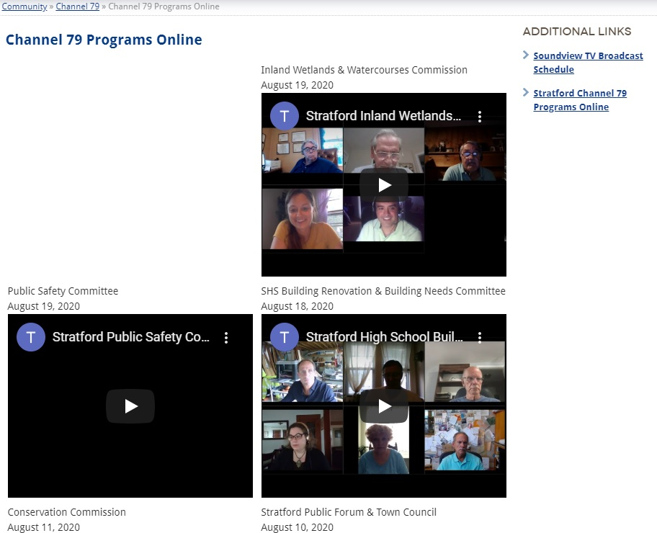

Town of Stratford Webpage
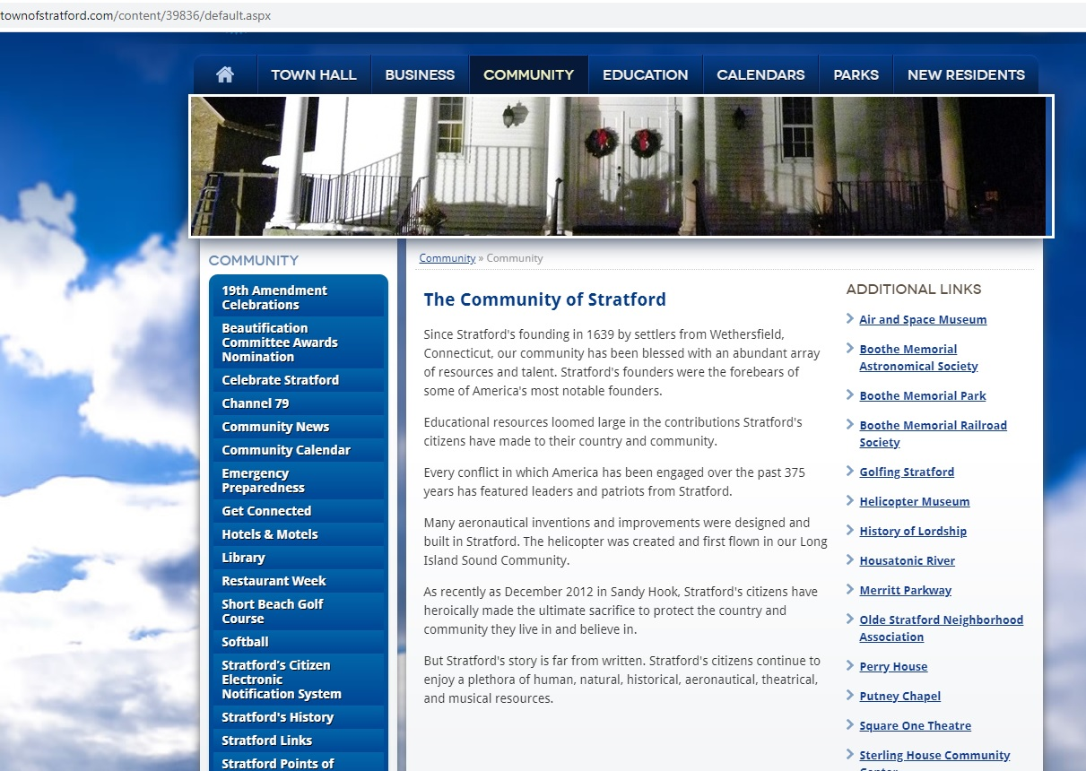

Mayor’s Newsletter
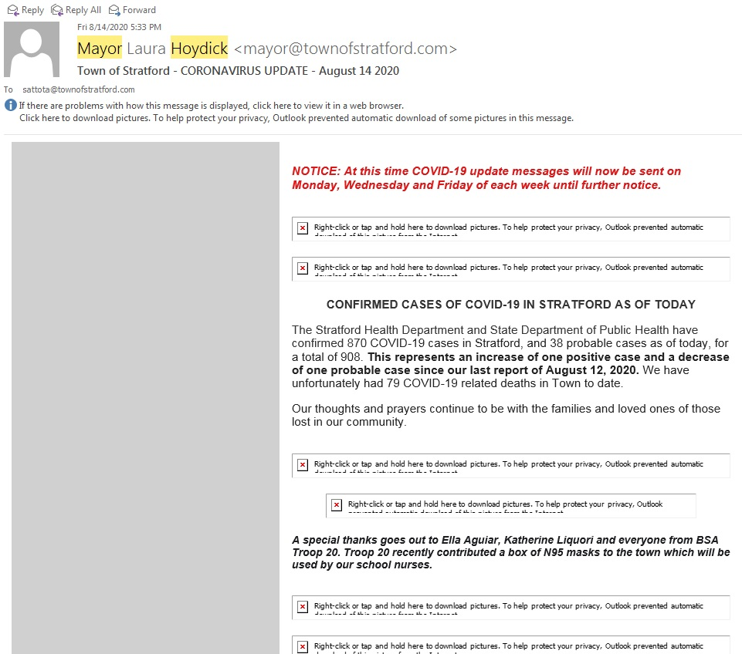

Town of Stratford Facebook Page
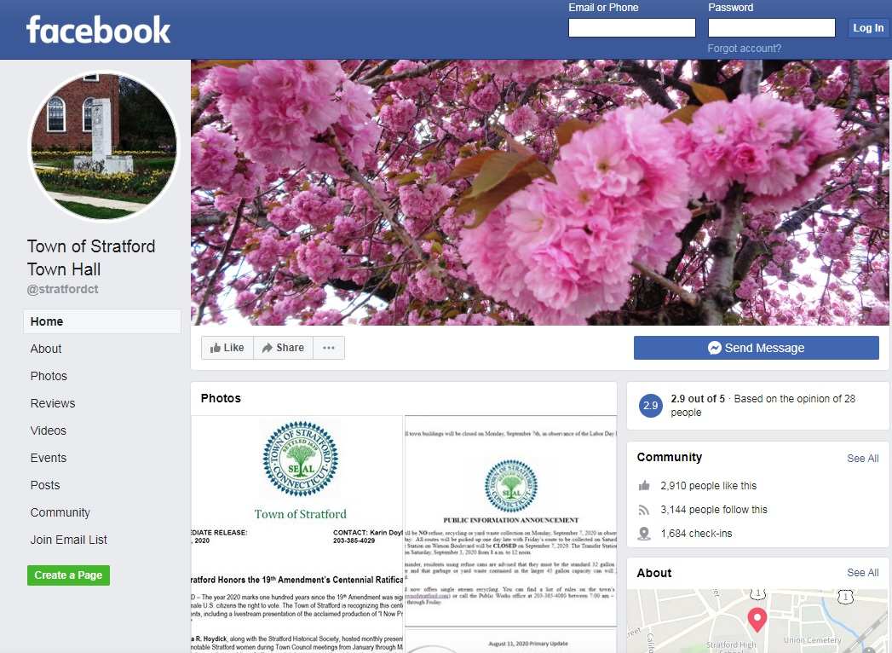

Town of Stratford Twitter Page
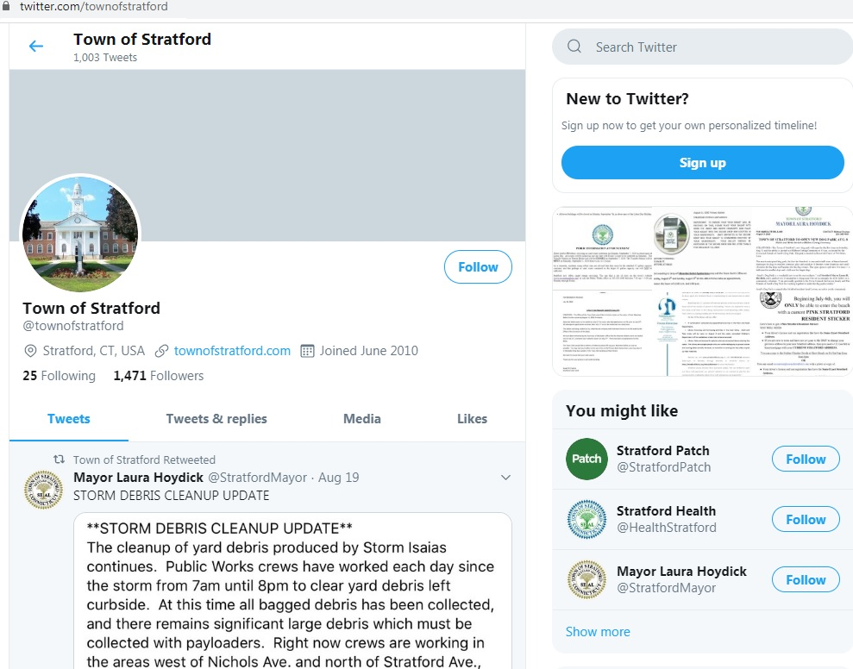

Stratford Police Department Facebook Page
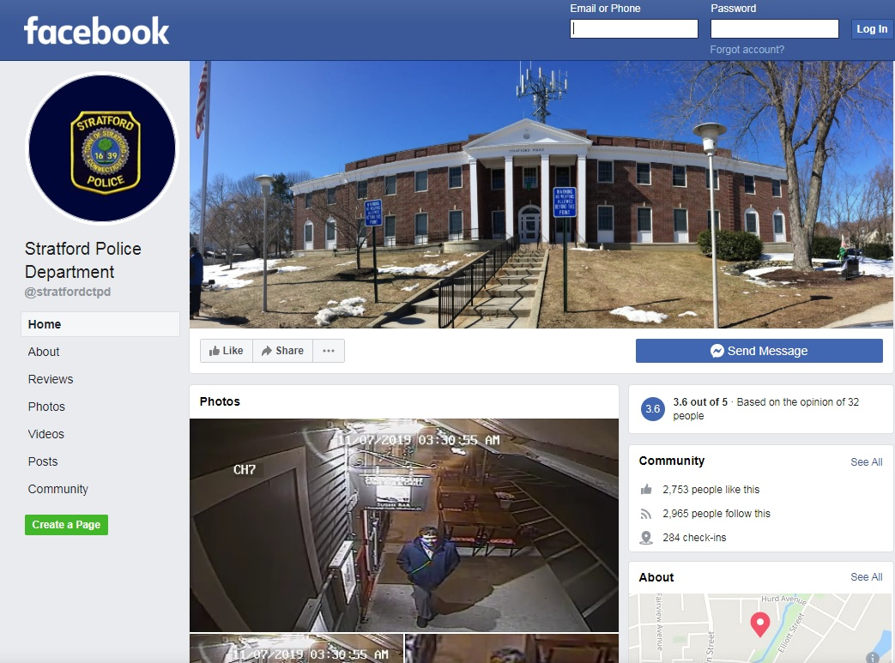

Stratford Parks and Recreation Facebook Page
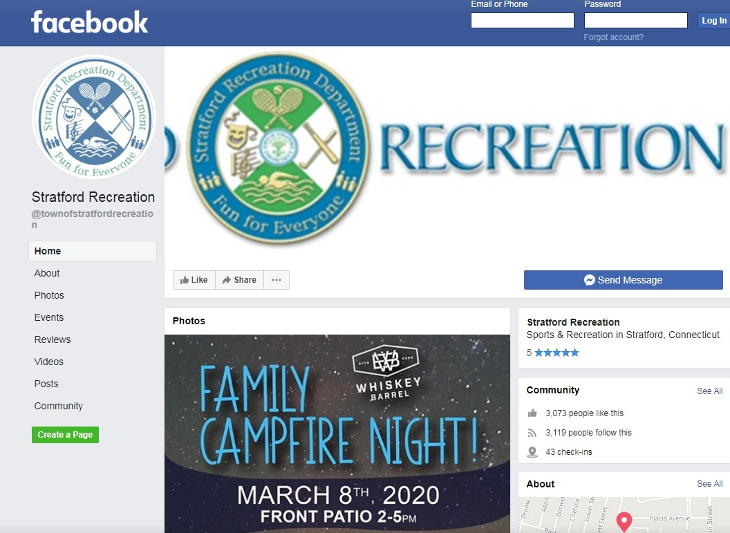

Stratford Economic Development Facebook Page
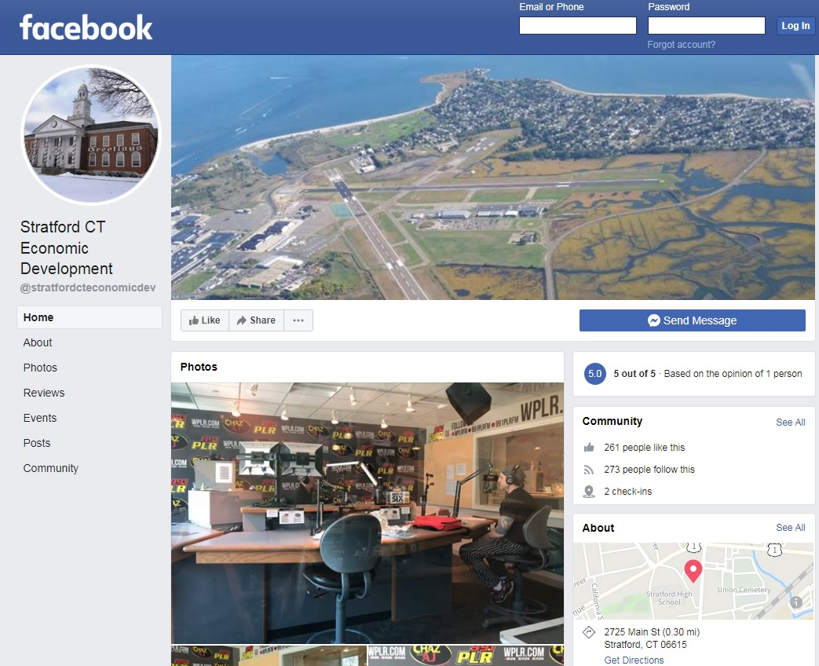

Celebrate Stratford Facebook Page
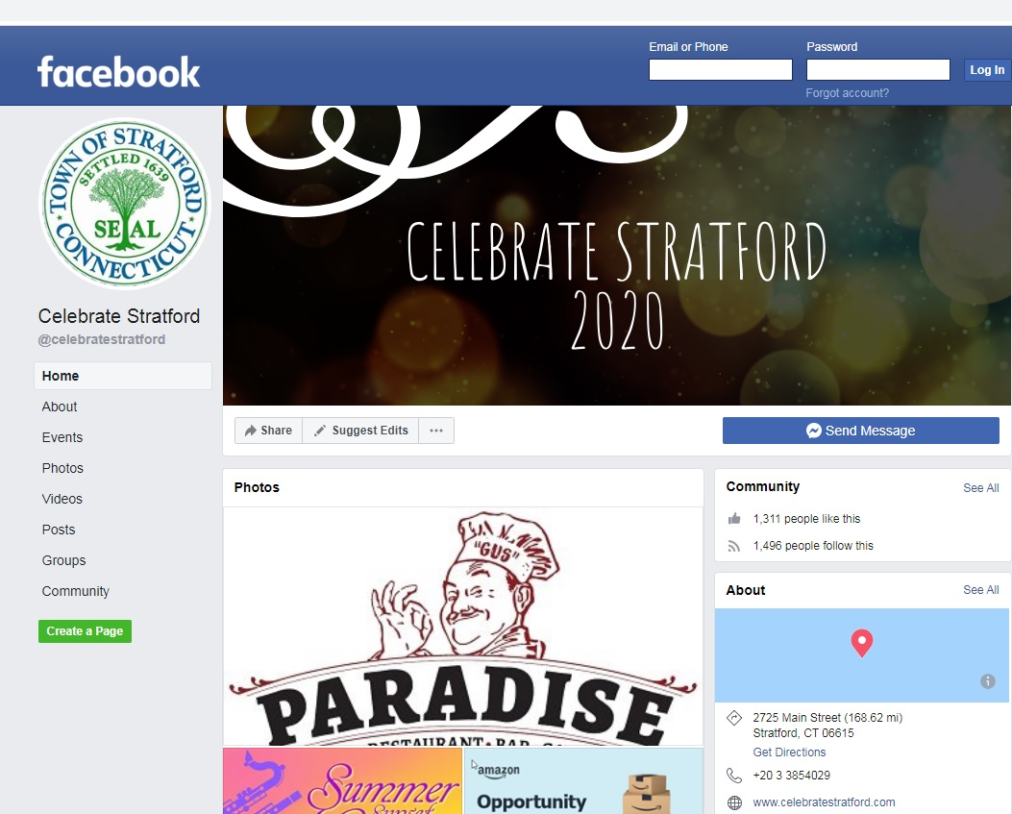

Stratford Public Schools Facebook Page
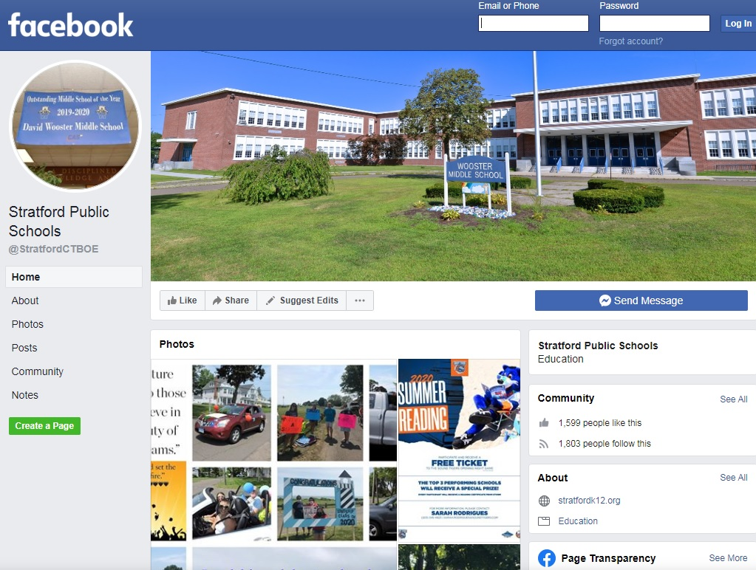

Planning and Zoning Online Permitting Link
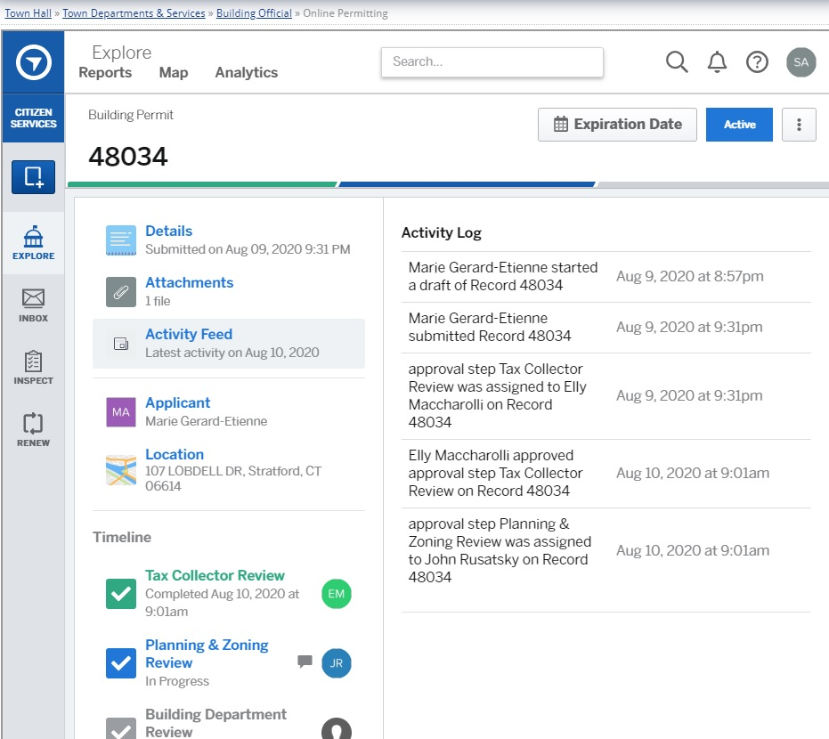

Stratford Citizen Electronic Notification System
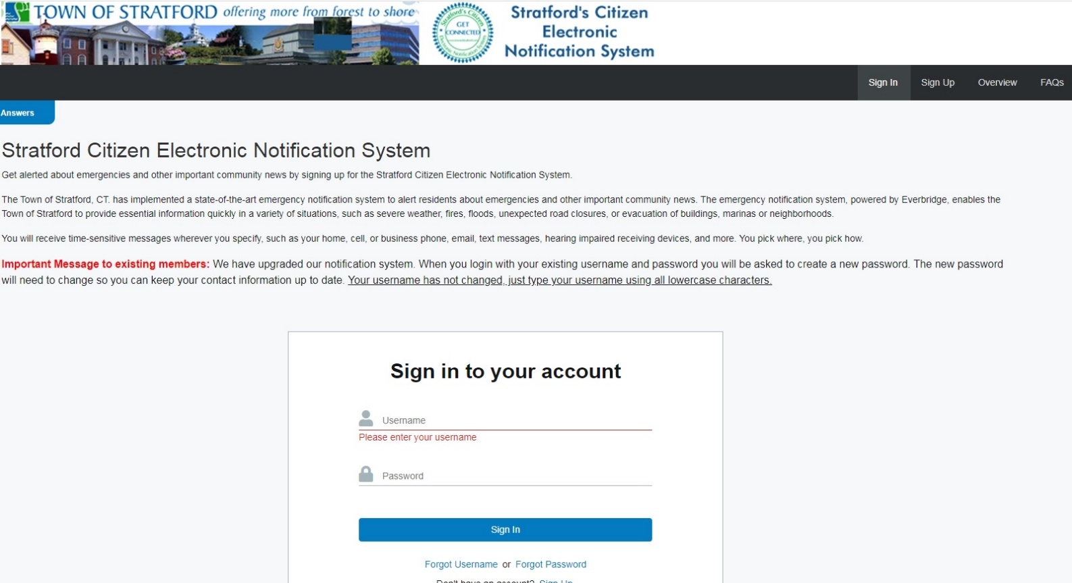

Stratford 411 Mobile App
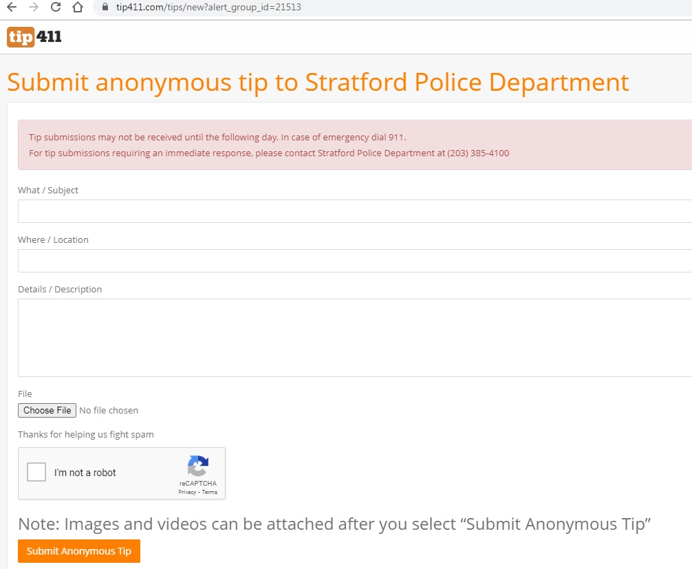

Stratford Emergency Management Services (EMS) Facebook Page
