10.1 Implement Your Own Sustainability Action
Total points requested for action: 10 (40 combined with CHEER)
Municipality: Middletown

10.1 Collaborate within your community to implement a sustainability action
To frame this submission, we will begin by replying to a concern raised up by Jess LeClair in an email to the city’s sustainability coordinator intern, Ingrid Eck – which can be seen in the “Notes” section of this submission. Forest City Farms does not host annual community events directly in collaboration with the City. Forest City Farms’ primary function is to grow food, as opposed to host community events. Although occasionally the farm will do so, these events are independent of the City. Forest City Farms also goes beyond 4.3.2 “allow active agricultural use of municipal land” because the allowance is only on the condition that the farm meet certain requirements: i.e., partnering with local soup kitchens and food pantries.
Aside from these concerns listed above, Jess LeClair had none regarding the action submission (see “Notes”).
In 2015, the city government granted a farmer, Gabriel Russo, 4 city-owned parcels of land in exchange for him providing reduced cost CSA shares to low- and moderate-income folk. Increased access to healthy and affordable food benefits the municipality immensely. Forest City Farms also hosts annual community events like Pick Day. Middletown residents, including the mayor, have a lot of pride in the program because it is unique to Middletown. In addition to donating produce to St. Vincent De Paul Soup Kitchen and Amazing Grace Food Pantry, the farm also sells its produce to several local restaurants: Herd, OSA, ION, and Café 56. This information has been confirmed by Middletown’s mayor.
See the following hyperlink to Forest City Farm’s “About” web page: http://www.forestcityfarms.com/about.html
See the following hyperlink to their homepage, which includes an informative video highlighting the above information:
http://www.forestcityfarms.com/about.html
Evidence of ongoing activity of the farm can also be found on their website. At the bottom of the homepage, it is shown that their organic certification currently applies until 2020.
See the below screenshot:
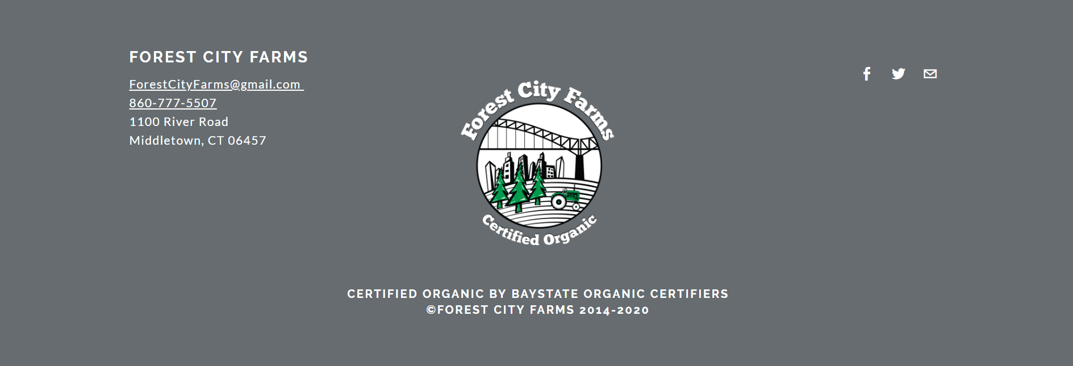

Further evidence of continued activity can be found on the Connecticut Department of Agriculture’s website, which is kept up to date:
https://portal.ct.gov/DOAG/Marketing/Marketing/CSA-Listing
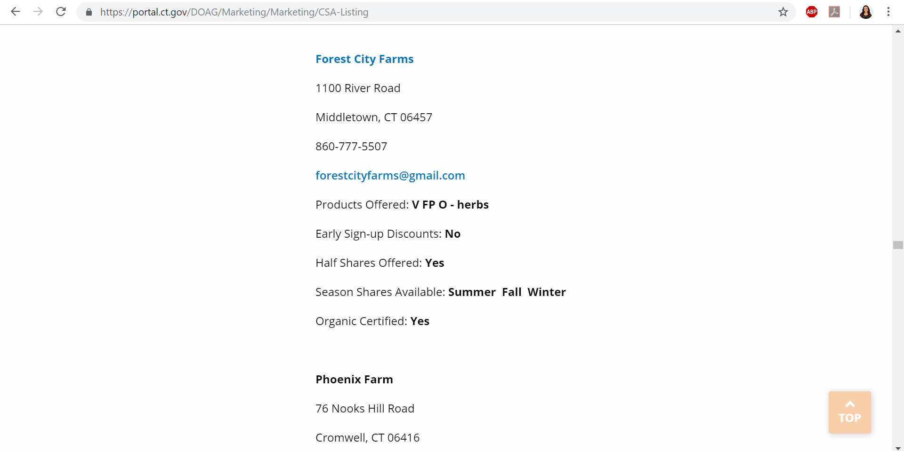

A final piece of evidence for continued activity is its actively maintained Facebook page:
https://www.facebook.com/forestcityfarms/
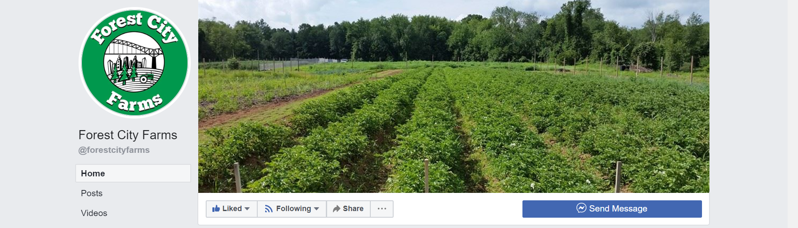
See the following hyperlinks to a variety of articles written about Forest City Farms and its establishment:
https://www.middletownpress.com/news/article/City-of-Middletown-partners-with-Forest-City-11765986.php
https://www.courant.com/community/middletown/hc-middletown-forest-city-farm-csa-0809-20170810-story.html

See the following hyperlink to a posting about a 2017 event with the farm’s supervisor:
https://www.rockfallfoundation.org/event/meet-your-greens-with-gabe-russo-of-forest-city-farms/
See the following Forest City Farms photo slideshow:
https://www.courant.com/community/middletown/hc-forest-city-farms-in-middletown-20170818-photogallery.html

“Notes” uploaded by Sustainable CT regarding Middletown 10.1 submission:
I wanted to check in with you all about a potential Innovation Action submission for Middletown. In 2015, the city granted a farmer 4 city-owned parcels of land in exchange for him providing reduced cost CSA shares to low- and moderate-income folk. Forest City Farms also hosts annual community events like Pick Day. Middletown has a lot of pride in the program and I think including it in our 2019 submission would make a lot of people very happy.
I do realize the look-back period for an Innovation Action is 3 years. However, the program is ongoing and there has been recent discussion about possible expansion of the program. Even though Forest City Farms was officially established in 2015, would it be possible to earn points for the program since it is ongoing?
A:
What an awesome, awesome program! By all means, please submit this one.
The look-back period is intended to capture work that's happened within the past three years that may no longer be ongoing. If the program still has lasting impact, it should count for points.
Please make sure to frame the submission carefully though, so that there's no overlap with other Sustainable CT actions. For example, if Forest City Farms has annual community events in collaboration with the City, those are probably better submitted under 7.1.
If you want me to look at any specifics as you get closer to submitting, just let me know.
Go, Middletown! And I can't remember off-hand, but if CHEER is still going in full force, that can get points as well, since there are two innovation actions allowed this year.

