2.2 Create a Watershed Management Plan
Total points requested for action: 10 points
Municipality: Middletown
2.2.1 Inventory
In 2008, the City of Middletown co-published the Coginchaug River Watershed Based Plan with the Town of Durham and Town of Middlefield. It was reviewed and updated in 2011. The plan’s Advisory Committee included a representative from the Conservation Committee and the Chamber of Commerce, as well as Middletown-based nonprofits including the Jonah Center for Earth and Art and the Connecticut River Coastal Conservation District.
- Natural Resources Inventory
In the Coginchaug River Watershed Based Plan, written in 2008 and revised in 2011, the USDA Natural Resources Conservation Service inventoried the Coginchaug River and its tributaries to evaluate existing watershed characteristics, including land use/land cover, soil-based recommendations for stormwater management practices, wetlands within the watershed, analysis of pervious/impervious cover, municipal regulations related to water resources, a stream walk, geomorphic stream assessment, and watershed fisheries resources assessment. The plan includes 8 objectives with specific actions and best management practices.
See 2011 Revision p. 5 for table of watershed land use and land cover summary.
Maps of inventory (extracted from plan because of file size and available at https://www.ct.gov/deep/cwp/view.asp?a=2719&q=379296&deepNav_GID=1654#coginchaug) include:
- Map 2: surface and groundwater quality classifications
- Map 4: broad land use/land cover
- Map 5: detailed land use/land cover
- Map 6: soil suitability for stormwater basins
- Map 7: soil suitability for stormwater infiltration systems
- Map 8: soil suitability for stormwater wetland systems
- Map 17: streamwalk survey areas
- Map 18: stream order
- Map 19: stream type

- Mapped and identified critical watershed resource areas
Wetlands, reservoirs, dams, and riparian areas with or lacking buffers are mapped within the plan. There are no aquifers within the area (http://cteco.uconn.edu/maps/town/apasmall/Middletown_apa.pdf).
Maps of wetlands, reservoirs, and dams from the plan are available at https://www.ct.gov/deep/cwp/view.asp?a=2719&q=379296&deepNav_GID=1654#coginchaug:
- Maps 1-2 identify river basins and streams, headwaters, as well as locations of reservoirs
- Maps 8-10 identify soil suitability for stormwater wetland systems, with indications of shallow marshes, ponds, pocket wetlands, natural wetlands, and constructed wetlands, all of which impact the watershed and wetland inflow and capacity ratings indicating poorly drained soils, very poorly drained soils, and floodplain soils.
- Map 24 identifies locations of missing streamside vegetated buffers and land use/cover.
- Map 29 identifies dam locations along the Coginchaug River.
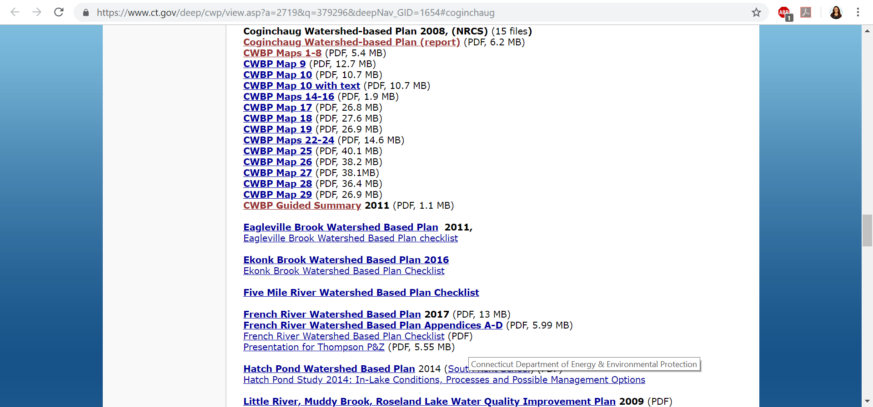

- Mapped land uses and locations where pollutant loads may enter watershed and estimates of pollutant loads using formulas
The Coginchaug River Watershed Based Plan is focused on base management practices for identifying and managing non-point source pollution in the Coginchaug River and its tributaries, primarily through bacterial and nutrient pollutant loading and poor water quality conditions. The plan also identifies place-based locations that have a high potential for bacterial loading based on land use, land cover, soil types, and other factors.
See pages 8 and 9 of the 2011 revision, which identifies multiple locations of locations where pollutant loads may enter watersheds:
- 51 segments of unbuffered streams
- Sewer line under Coginchaug River
- Veteran’s Park snow pile
- Laurel Brook Reservoir
- Wadsworth Falls State Park pond
- Route 66 commercial districts
Runoff potential acreages and percentages are indicated in the maps below, which are available at https://www.ct.gov/deep/cwp/view.asp?a=2719&q=379296&deepNav_GID=1654#coginchaug:
- Map 14: runoff potential based on soil properties
- Map 15: runoff potential based on land use/land cover
- Map 16: runoff potential for soil/land use
- Map 22: agricultural operations
- Map 23: subsurface sewage disposal systems
- Map 24: locations of missing streamside vegetated buffers and land use/cover
- Map 25: analysis of agricultural and other sources of waste
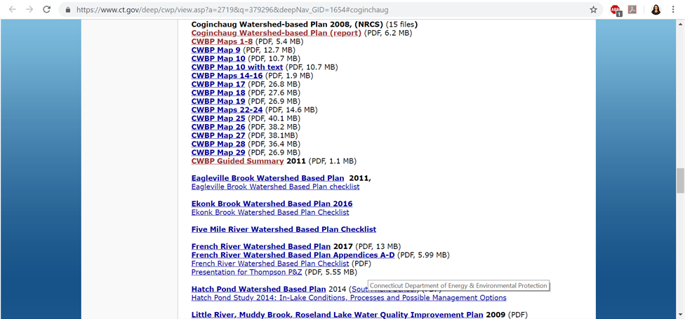
Points requested for sub-action: 10

Additional submission documents:
- Coginchaug River Waterbased Plan 2008
-Coginchaug River Waterbased Plan 2011 Revision
-Aquifer Protection Areas Map

