7.5 Report Materials Management Data and Reduce Waste
Collecting and reporting waste and recycling data
Points requested: 5 points

Sub-action 1 for “Collecting and reporting waste and recycling data”
Kim O’Rourke, Middletown’s Recycling Coordinator, is responsible for collecting data on municipal solid waste and recycling and reporting that data to the Connecticut Department of Energy and Environmental Protection (DEEP). Below is her contact information:
245 Dekoven Drive
Middletown CT 06457
860-638-4855
kim.orourke@middletownct.gov

We have publicly disseminated all the data regarding Middletown’s annual solid waste generated and residential solid waste recycled from 2013 to 2017 on the City’s website. It can be found on the Recycling Program Information page and through the link called “Middletown Waste and Recycling Tonnages.”
http://www.cityofmiddletown.com/content/117/121/167/1862/default.aspx
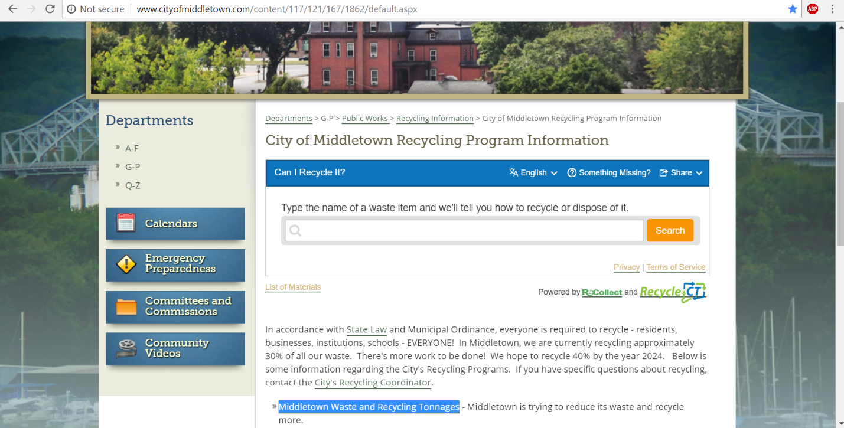

Below is data regarding Middletown’s population, provided by CT State Department of Health.
2013: 47333
2014: 47043
2015: 46756
2016: 46544
No information has yet been released for 2017.
We have used this data as well as DEEP’s data to calculate MSW & Residential Recycling production per capita for the years 2013 to 2016. See a separate attachment for this information.

